**Report**

**on**

**FRONT-END ENGINEERING**

**CS186**

by

**Ankit Bansal**

**2110990202**

**G5**

**3rd YEAR**

**INSTRUCTOR’S NAME – MR. LAVISH ARORA**

**Batch 2021**

**Session 2023-24**



The project is based on an E-COMMERCE website for selling Allergy Groceries online and deliver them to any part of the country. The title for the website is ”Allergy Grocers”. It took around 60 days for me to complete the project. The website has around 20 pages, 8-10 out of which are entirely different and the rest are product based pages. The website is made with the idea that in india many people are suffering from so many allergies and my website focuses on selling those products.So this website could be great experience for the buyers in buying products easily and at best prices. The most challenging parts of the website have been the header and the home page for me as I wanted to have the best design and structure possible, so I browsed the internet to search for different ideas and came up with a black and white theme which I think is simple but elegant.

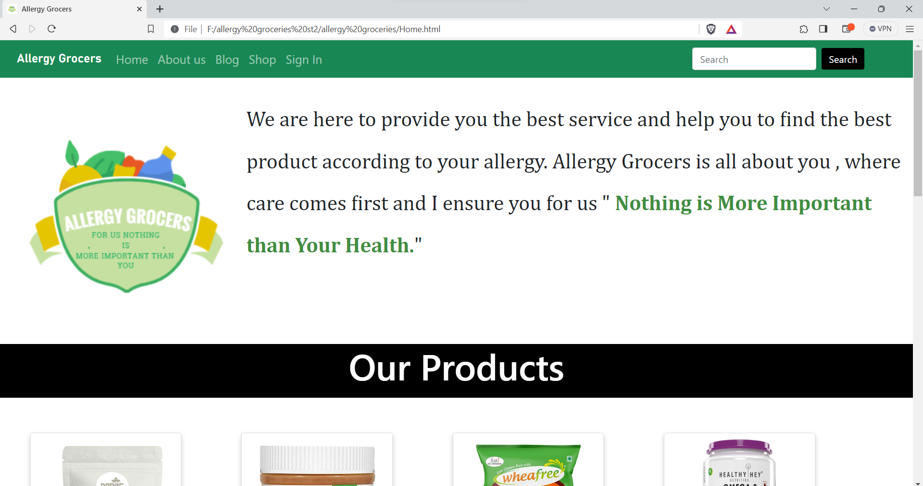

The page shown above is the **HOME PAGE** of the website, you can see the Logo of the website which says “Allergy Grocers” i.e also the title of the website. The website has been given a white and green theme.

On the top the user can see the **NAVIGATION PANEL** i.e the header, which is helpful in browsing throughout different pages in the website.

There are different options available on the navigation panel like “LOGIN”, “BLOG”, “SHOP”, “HOME”, “CONTANCT US”, “ABOUT US”, “THE SEARCH BAR”etc.

The **SHOP** option is a clickable button which takes the user to pages such as the wheat free, gluten free and nuts free and many more. Also there is a search bar, so that the user can easily search the desired product by just typing the name.

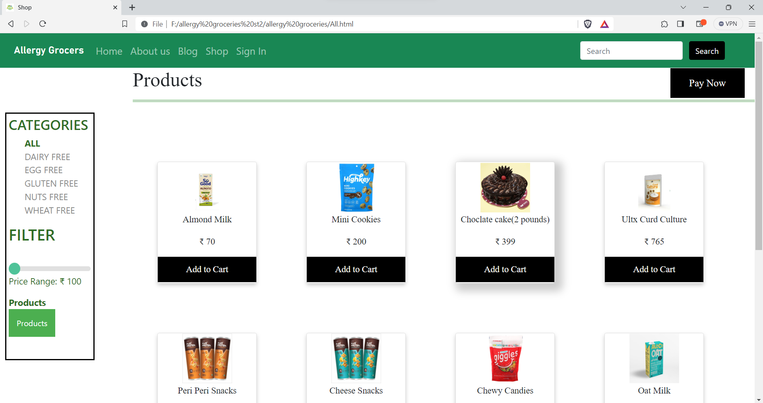

After the navigation panel, Come the posters for our hero products. These products are the latest and are selected on the basis of sales and style by our experts.

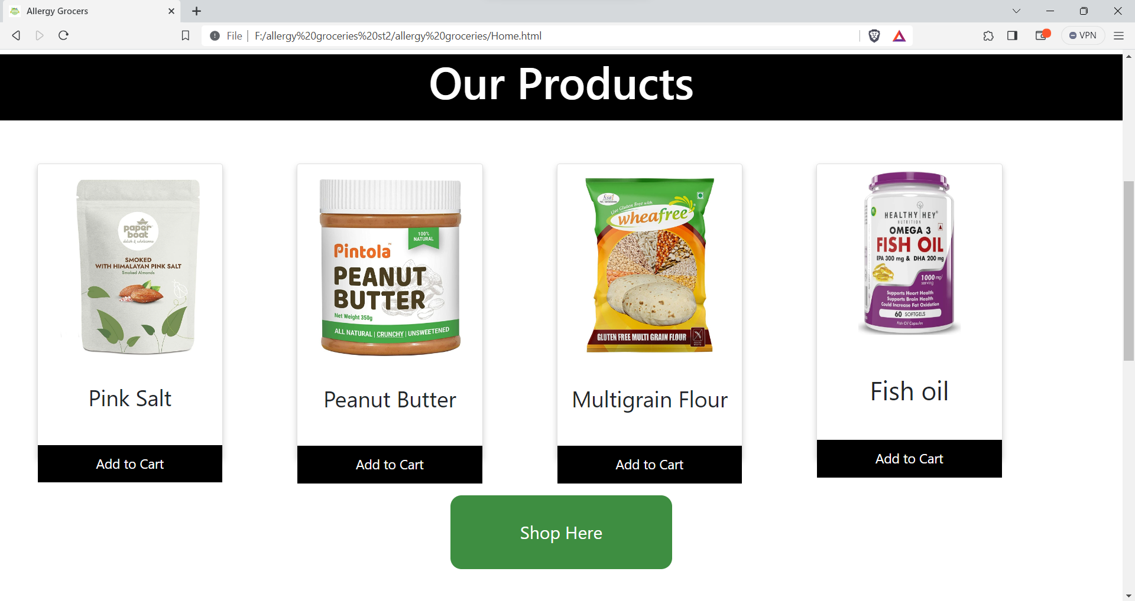

Then comes the **TRENDING PRODUCTS** section of the Home page. Where products are hand picked by the experts on the basis of selling number of products and durability.

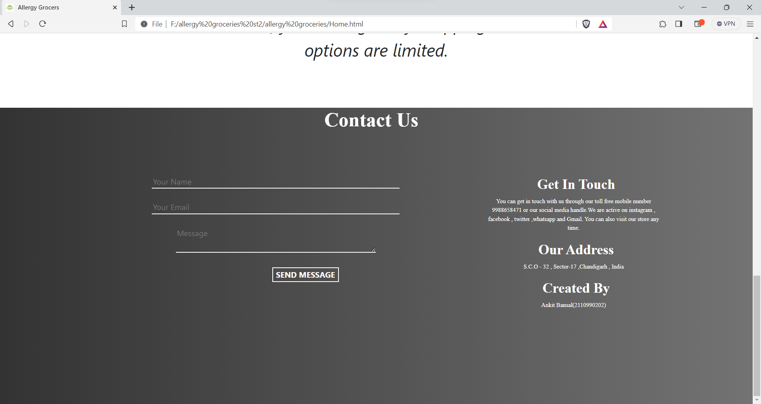

In the last we have the **FOOTER** of the website which consist of contact us, get in touch, option for subscribing to our newsletter through e-mail, link to terms and conditions, icons of payment options, etc.

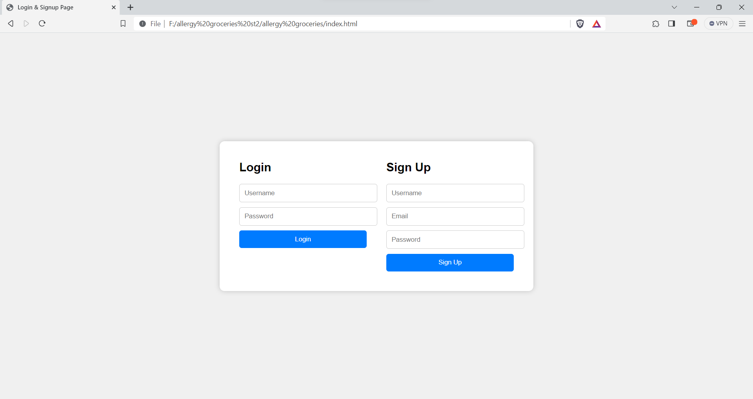

This is the **LOGIN PAGE** of the website where users can Login to their “Allergy Grocers” account by using their e-mail id and password. Also if a user doesn’t have an account in “Allergy Grocers”, then the user can sign up by clicking on “CLICK HERE” below the Login Button which will land the user to the **SIGN UP PAGE**.



This is the **SIGN UP PAGE** of the website where users can register themselves on “Allergy Grocers” by providing us with their personal details such as first name, last name, e-mail id, phone number and the password they would like to choose for their account.

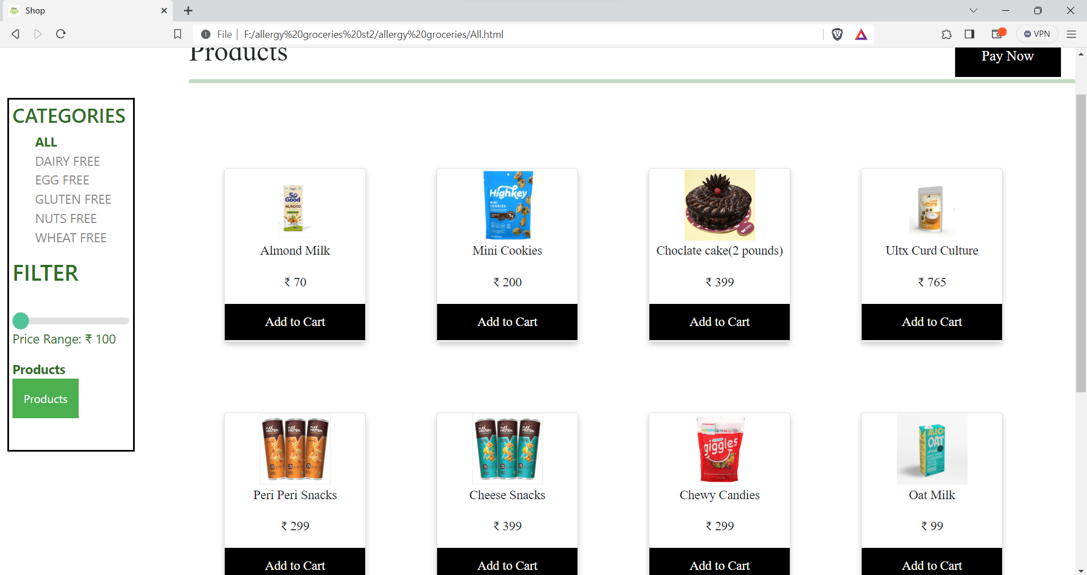

This is ALL category page where all the products have been shown. The side navigation box has PRODUCTS options where is a drop down list and shows different items like “cookies”,”snacks”,”waffles”.

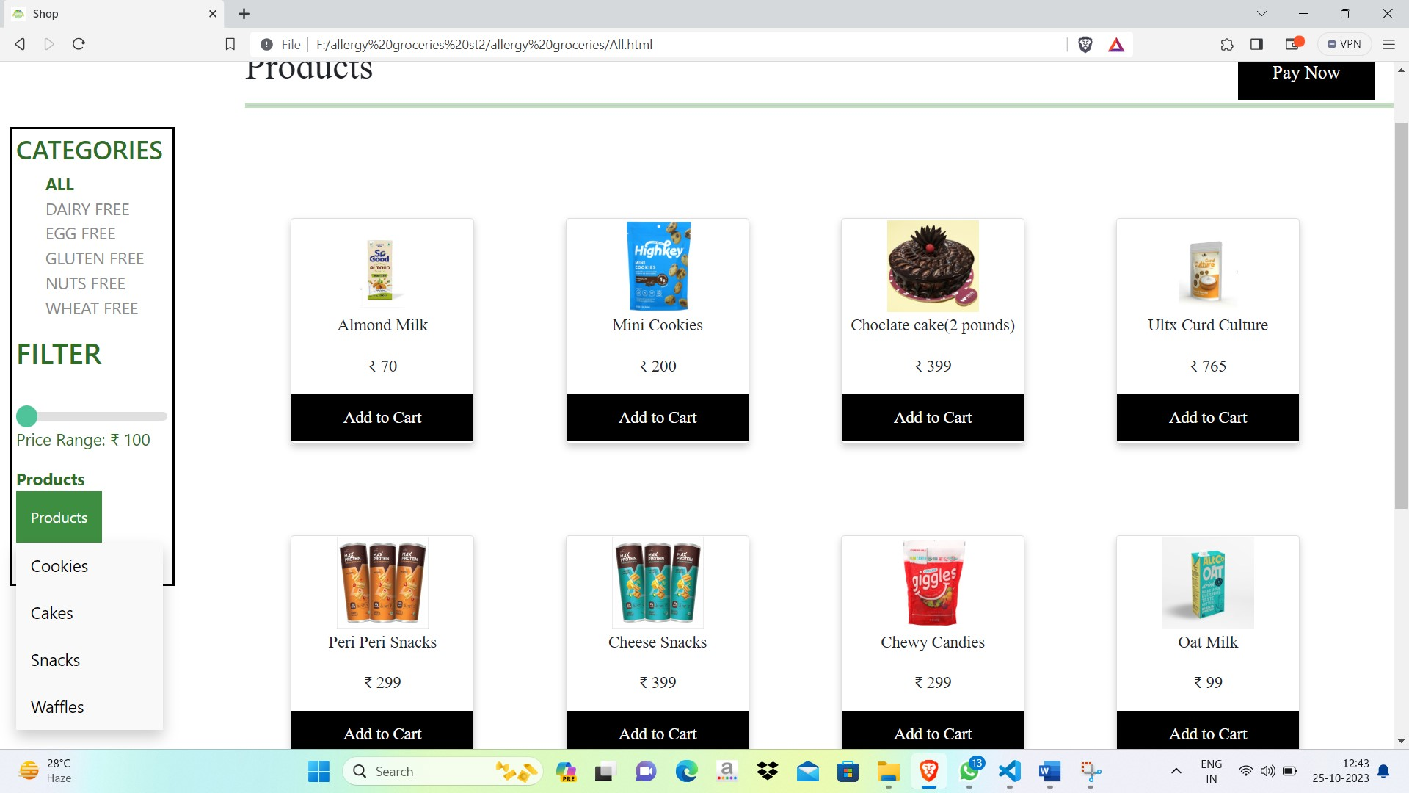



Below are the Screenshots for Dairy Free Products Page

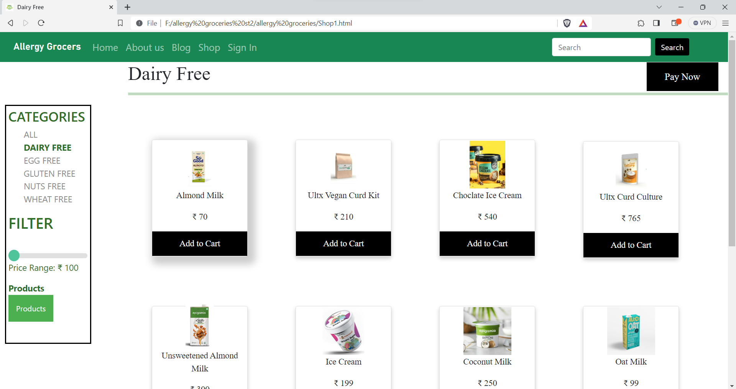

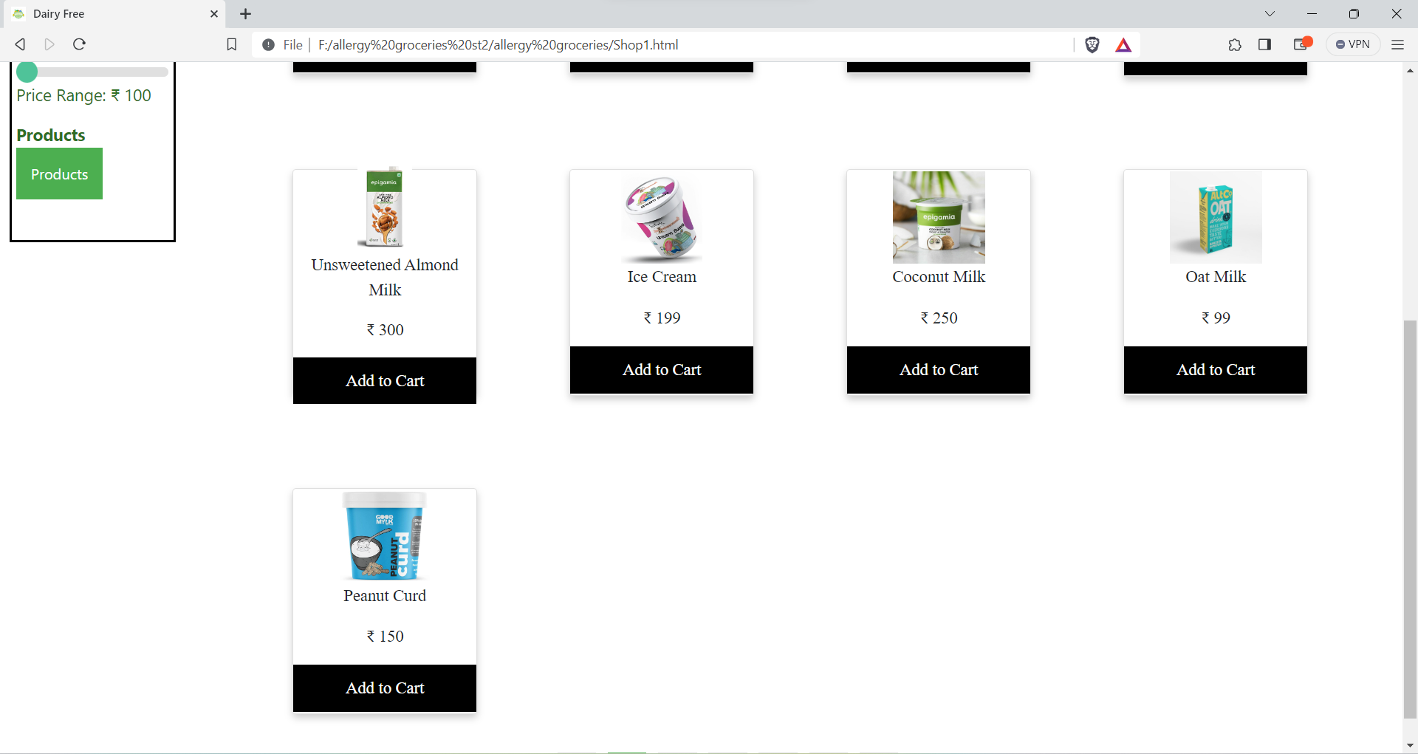

Below are Screenshots for Egg Free Products Page

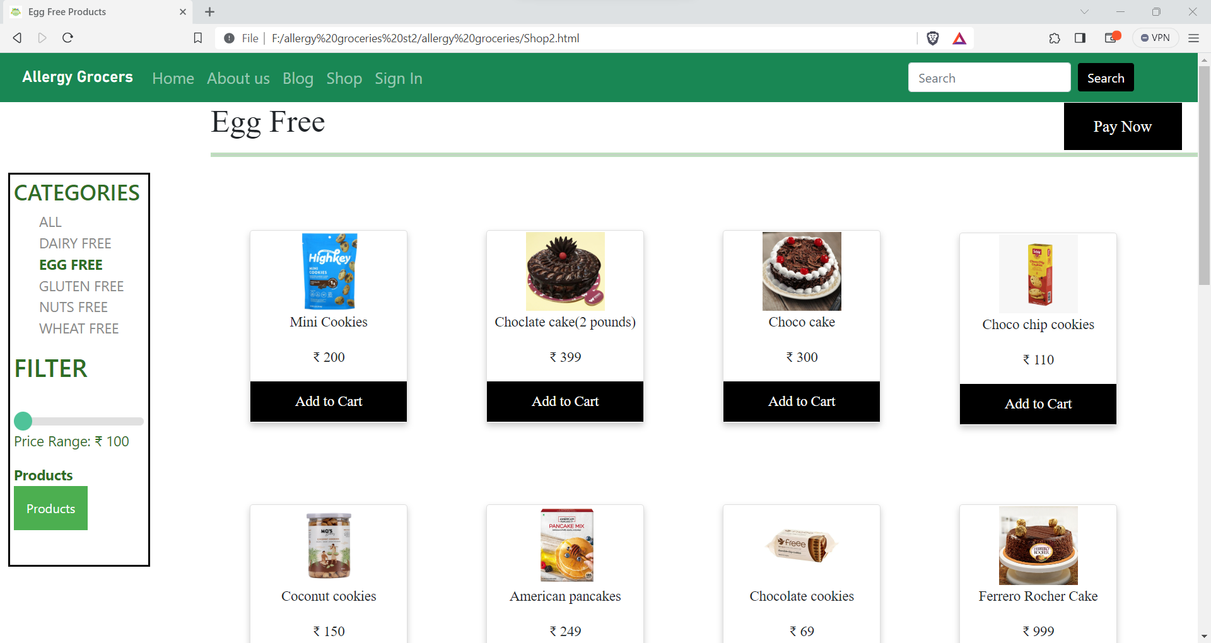

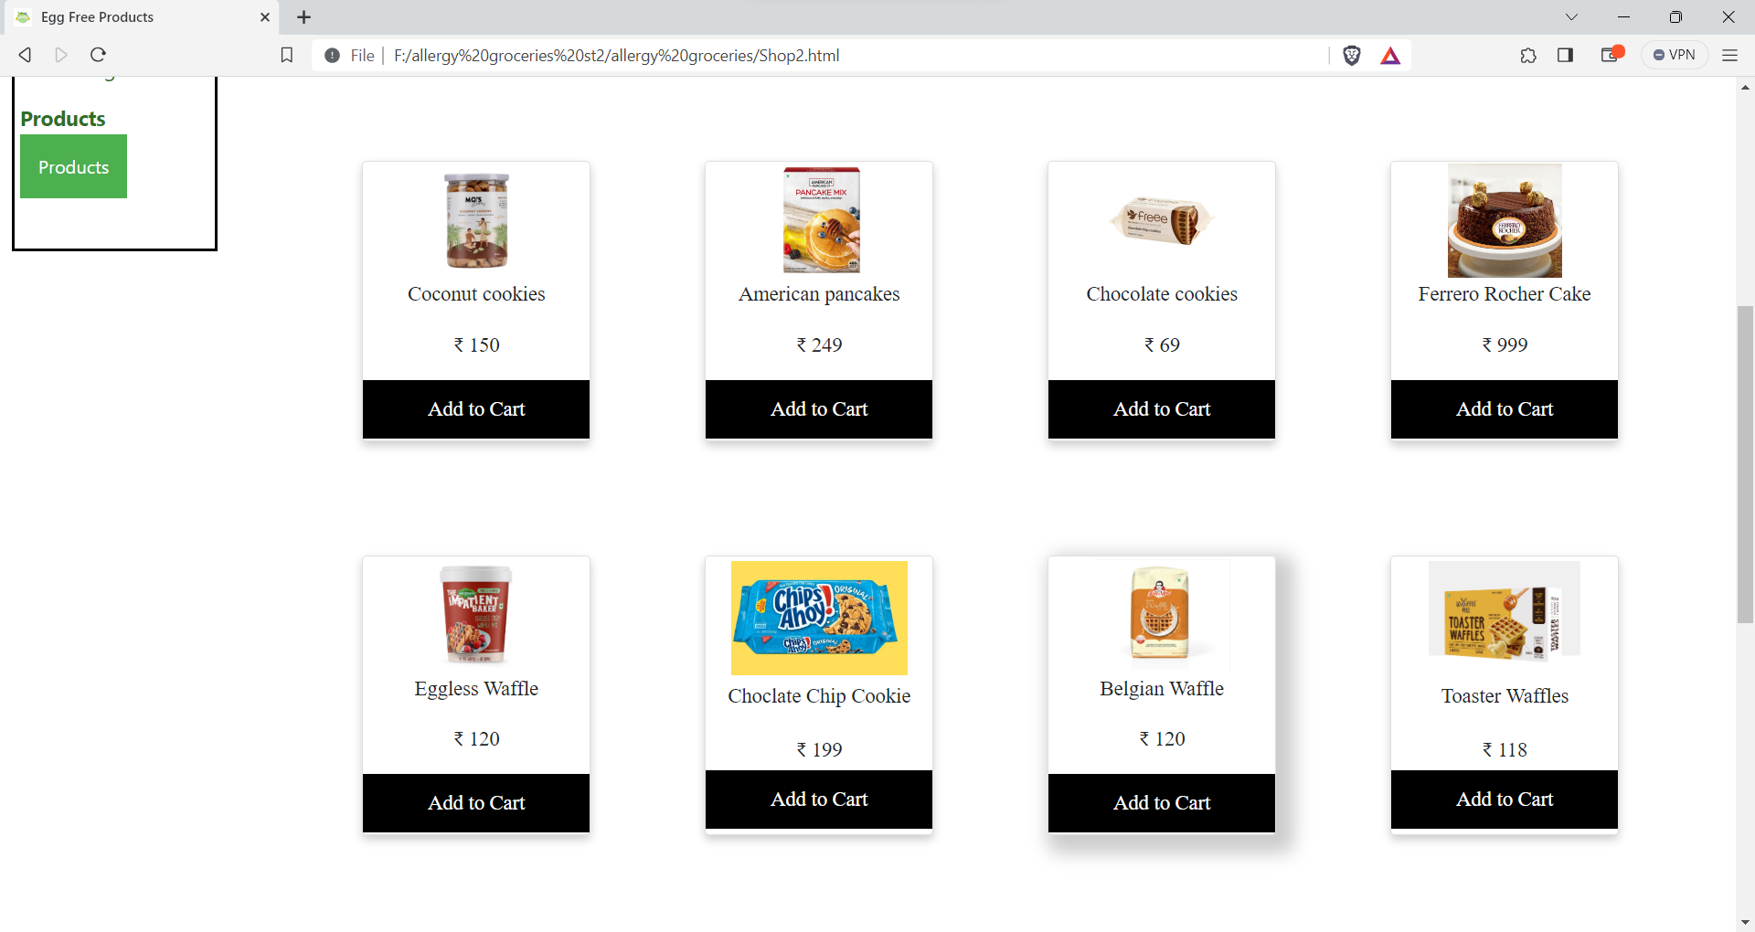

Below are Screenshots of Gluten Free Products.

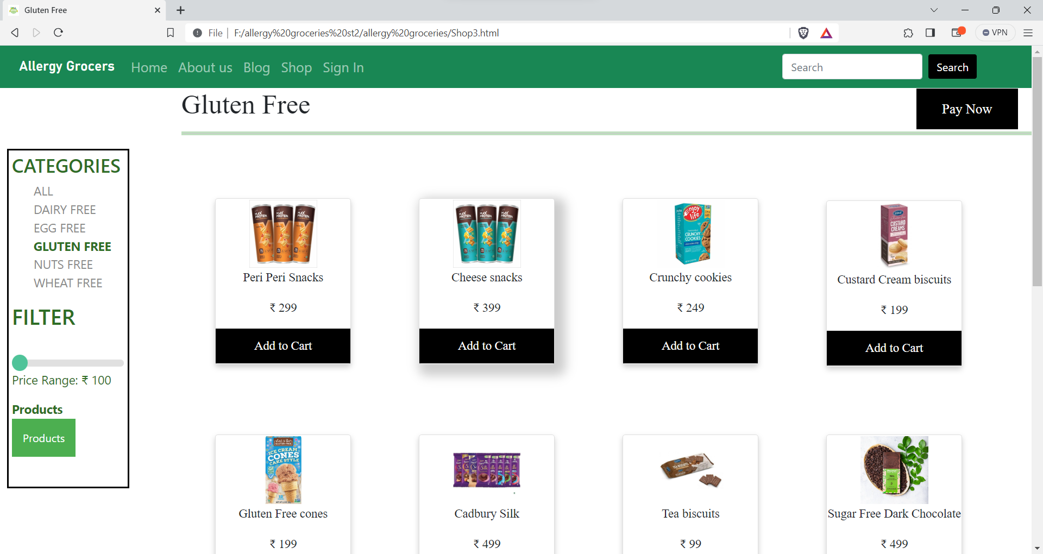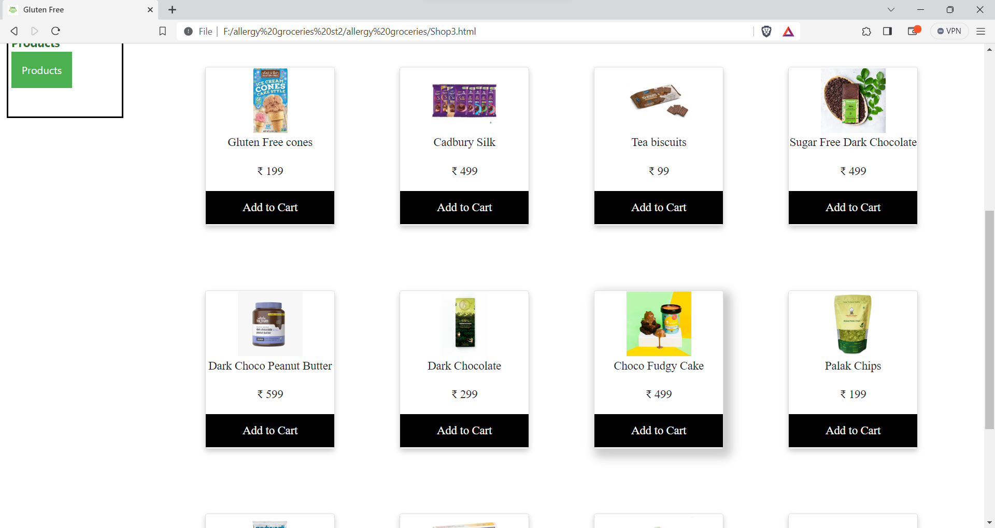

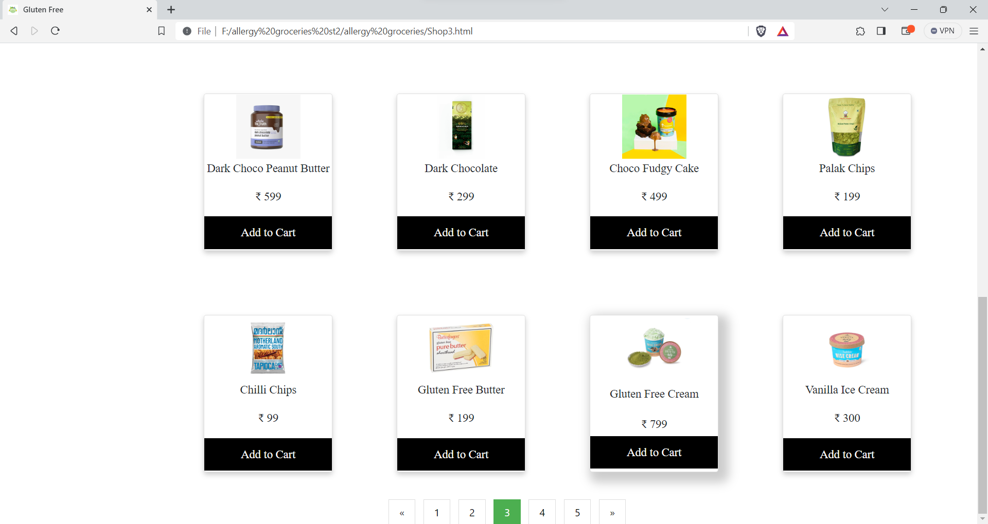

The navigation panel also has an option named as “SHOP” which on clicking lands the user to a page where all the products our website serves have been listed.

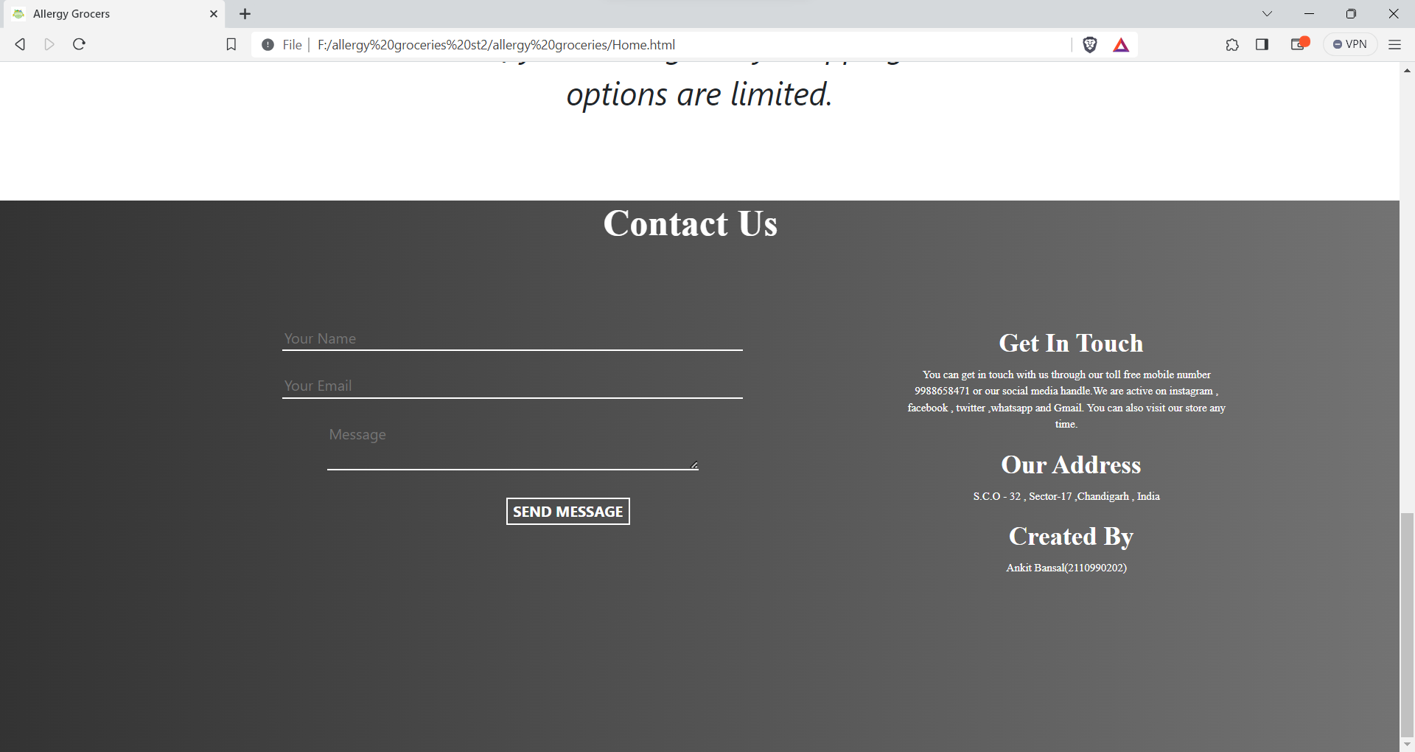

This is the Contact Us page which consist of a form, which can be filled by the user if he/she has any complaints regarding the website or any product. If the user wishes to visit our help center then he/she can click on the help center button and get the address of the nearest help center.





Below are Screenshots for the **ABOUT US PAGE**

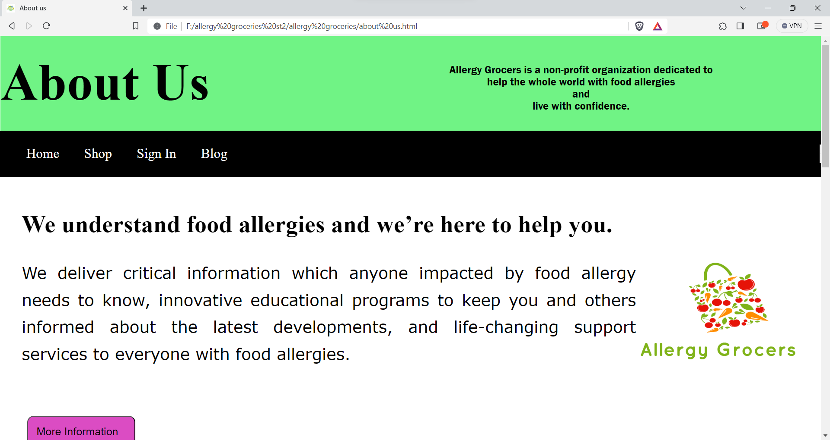

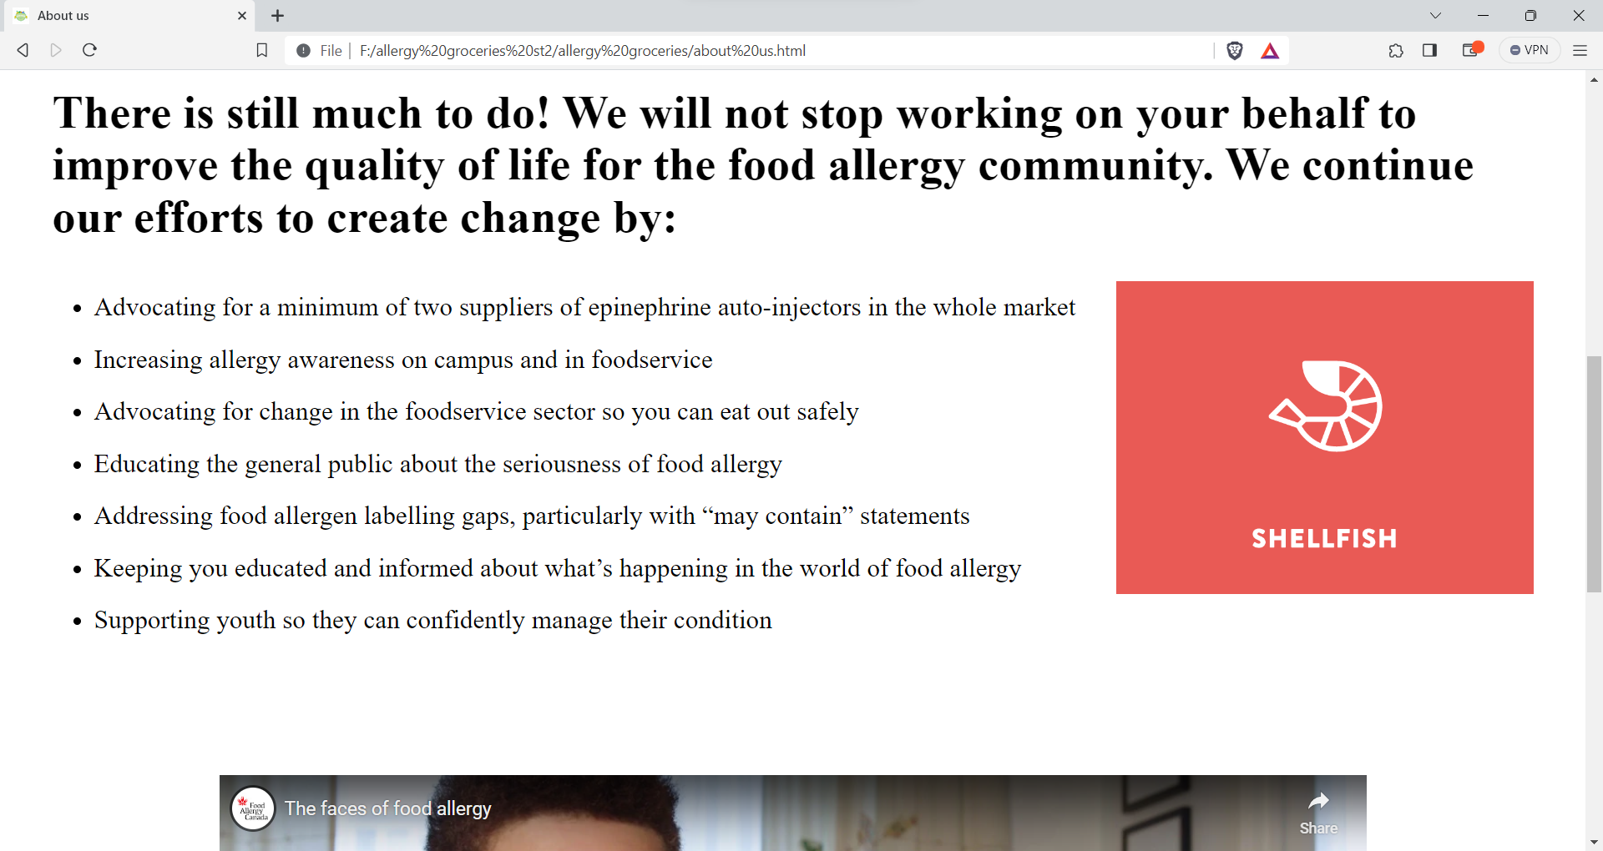



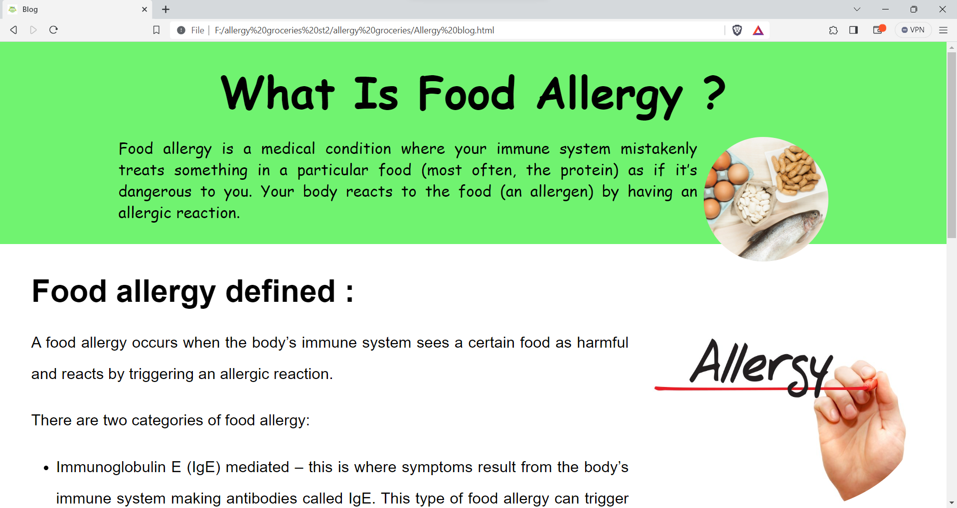

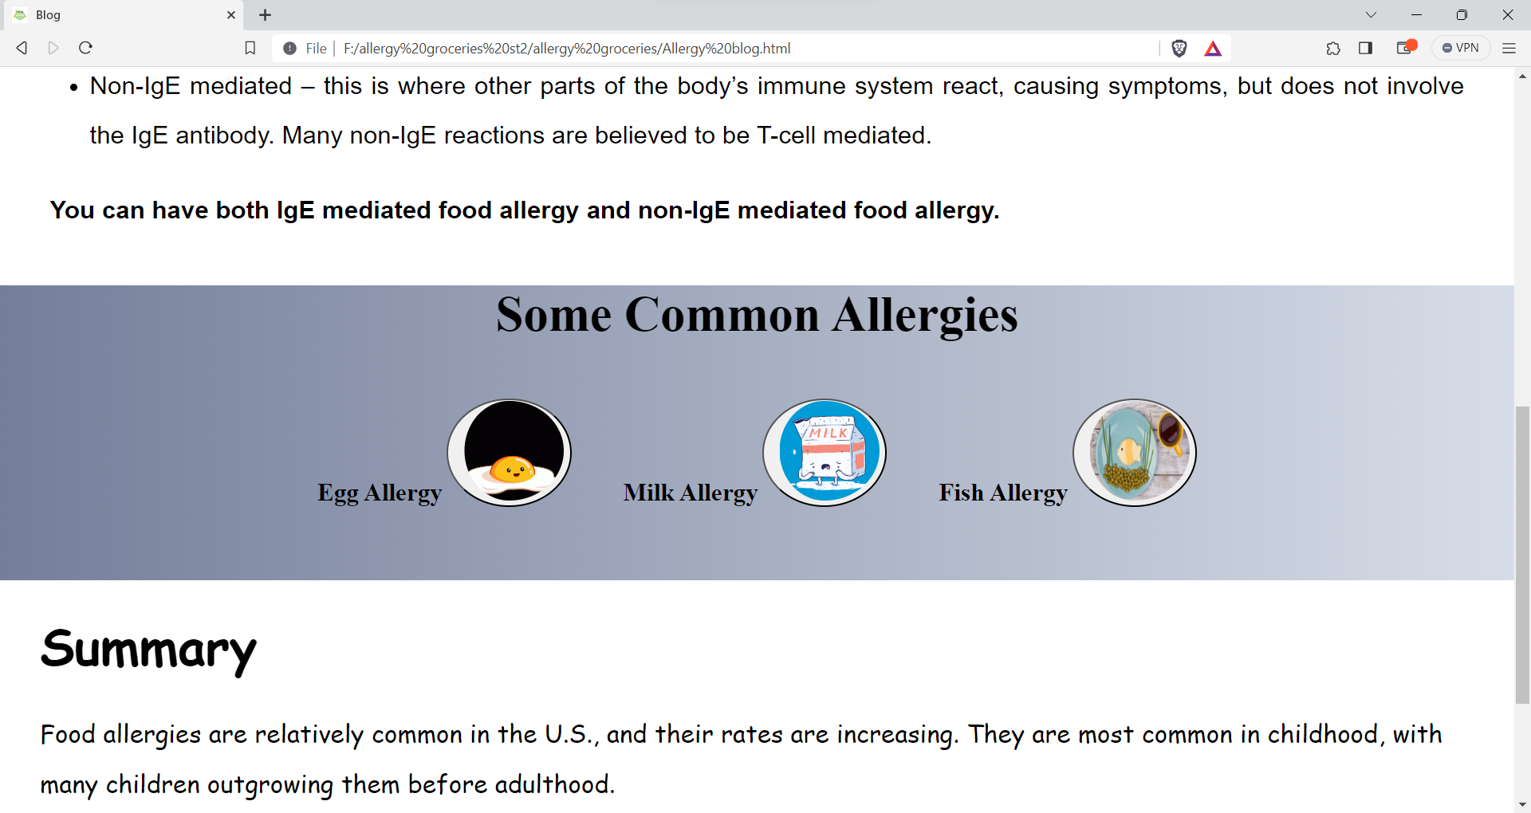

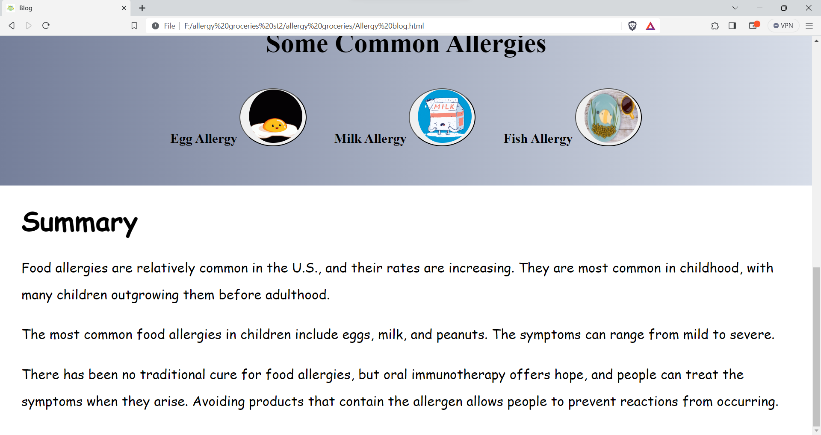

This is **BLOG** of the website, it gives us information about what is food allergy and summarises the food allergy content about the website.

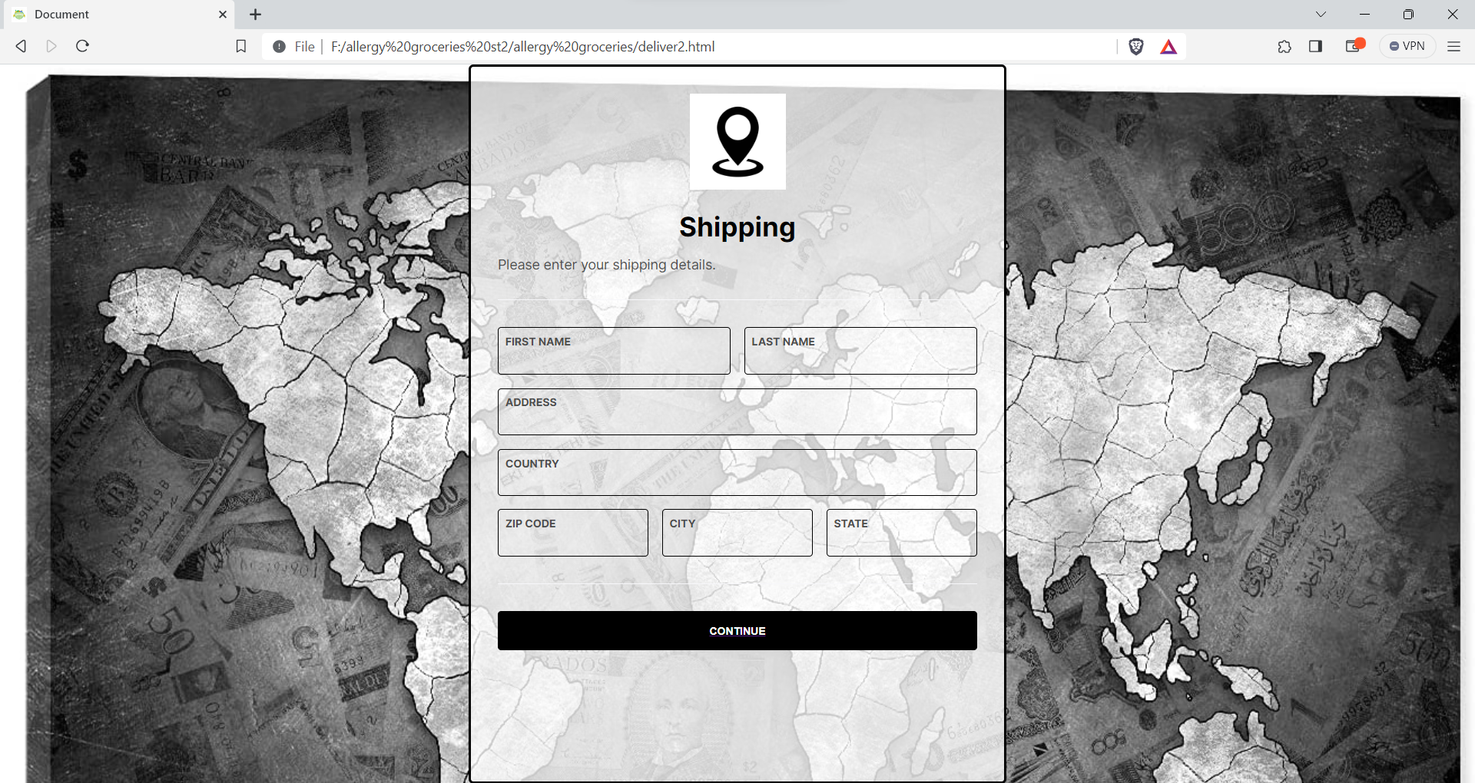

After clicking the pay now button the user lands on the shipping details page. The can here enter his/her address and contact number where they want the product to be delivered and then continue to payment gateway.

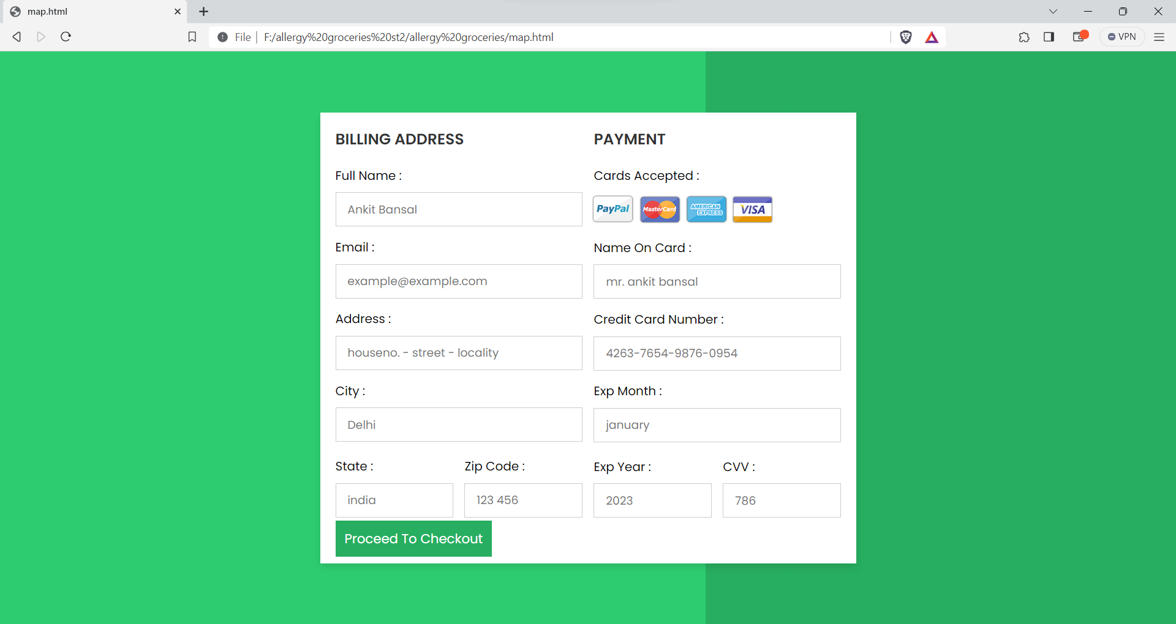

This is **PAYMENT GATEWAY PAGE**

The Card details are entered by the user and the payment will be successful. If this page is submitted without entering anything then it would show invalid input and the user has to enter the details in order to complete the order.

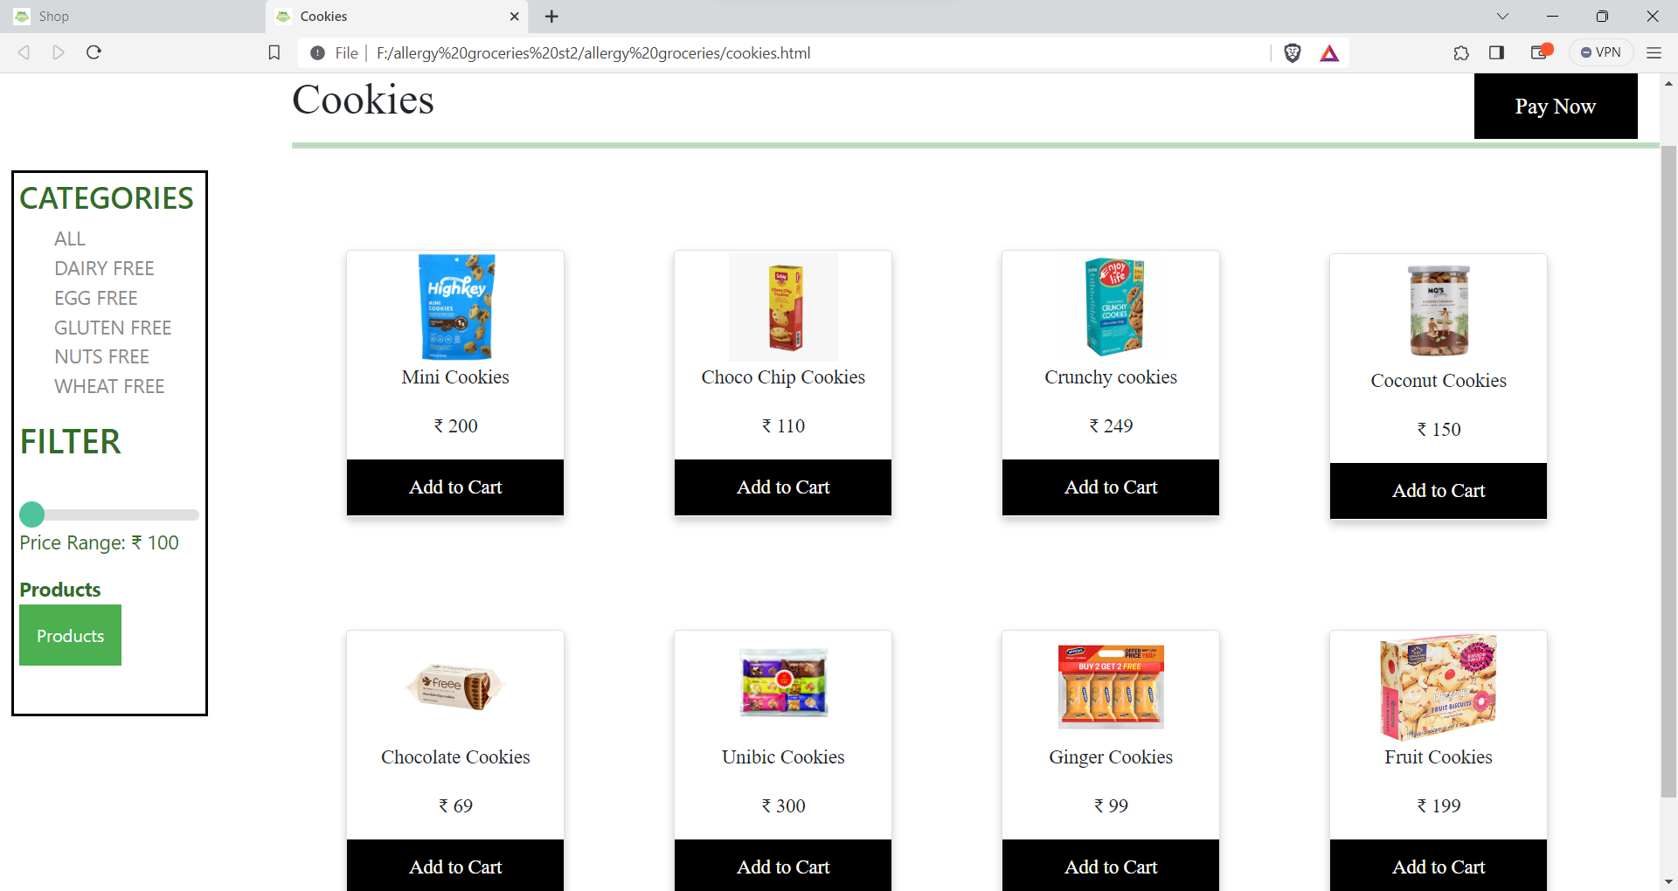

This is the **COOKIES** page of the website in which all the products named cookies gets listed so this is responsive thing of my website.

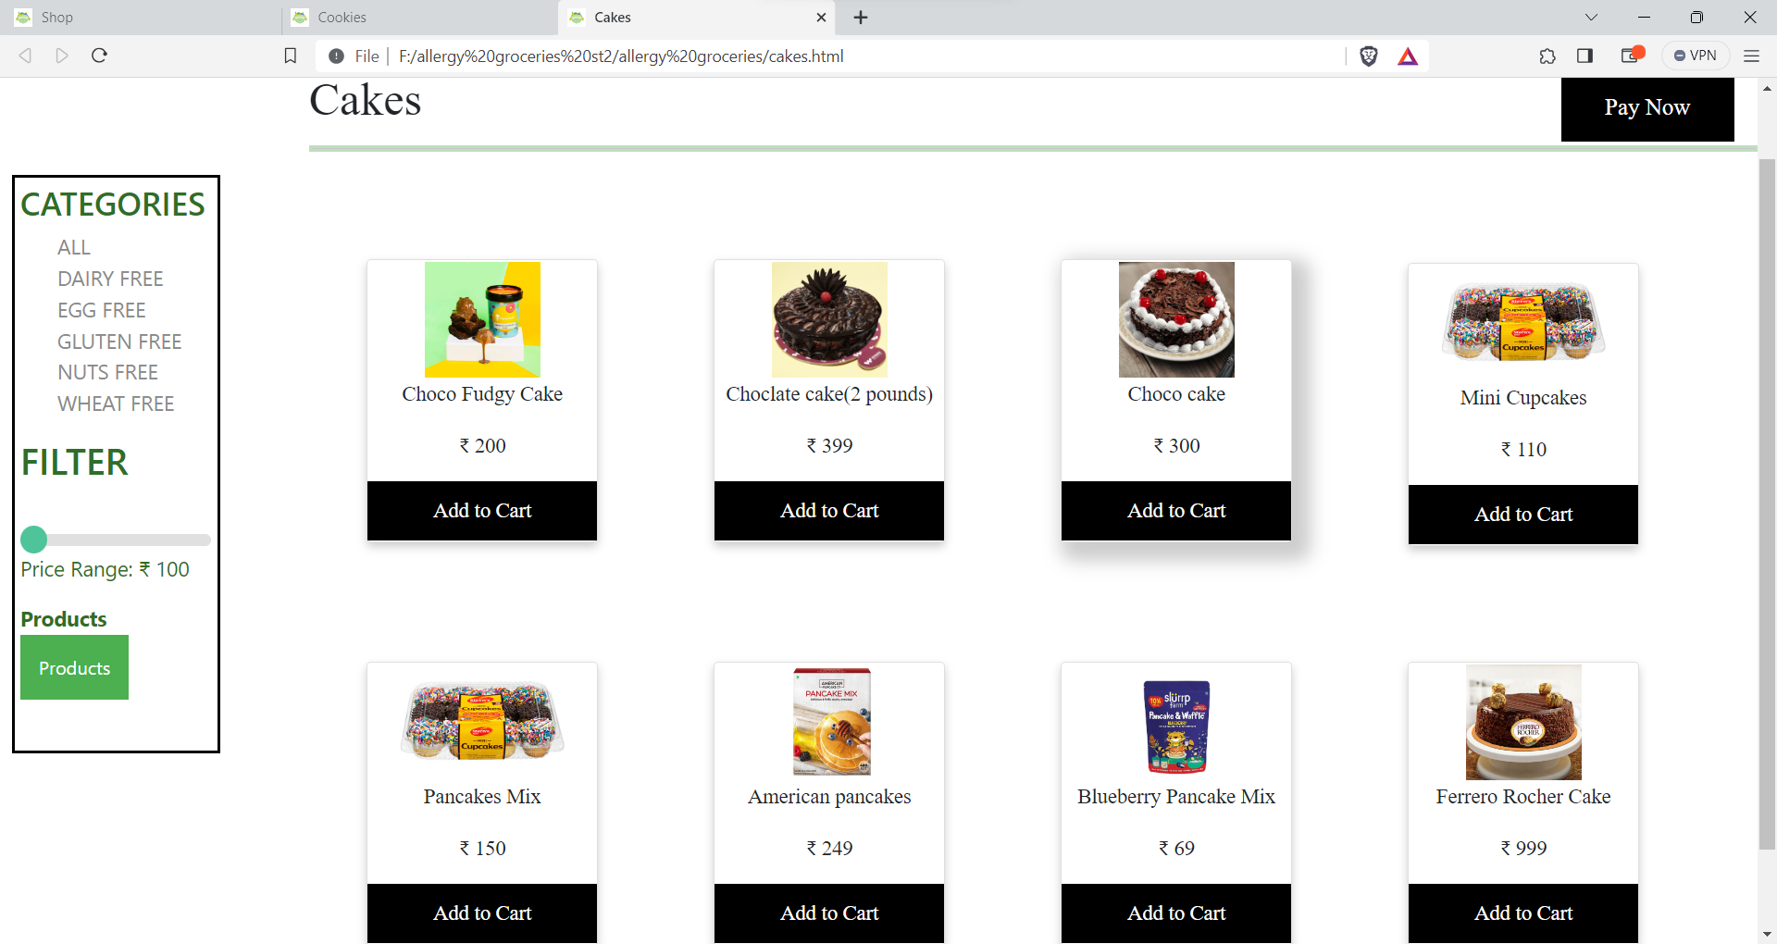

This is the **CAKES** page of the website in which all the products named cakes gets listed so this is responsive thing of my website.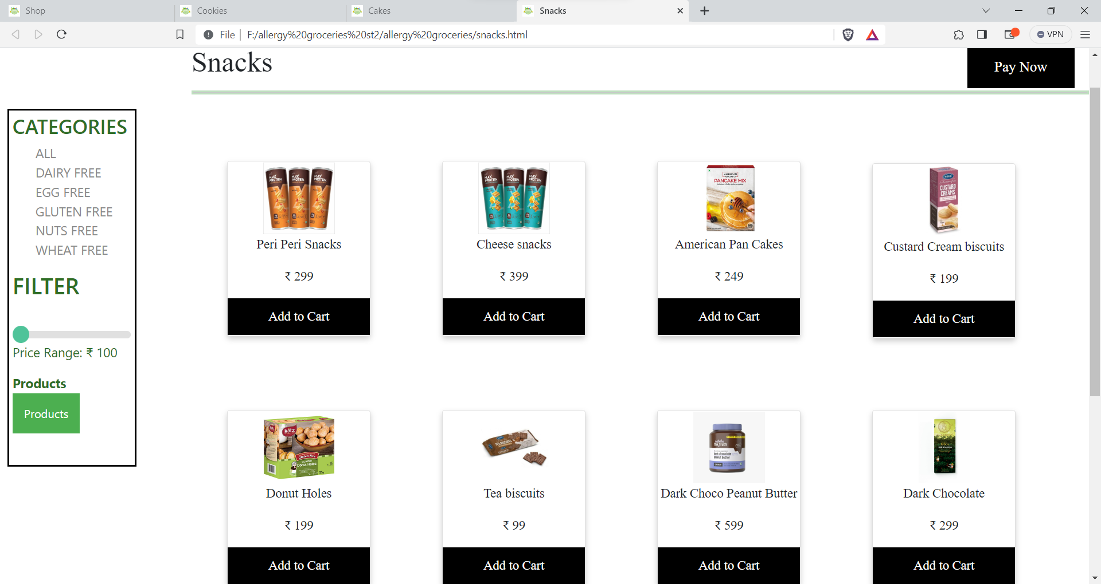

This is the **SNACKS** page of the website in which all the products named snacks gets listed so this is responsive thing of my website.

After then there is a feedback page where the user gives their feedback.